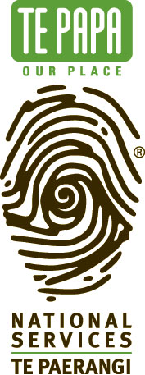
National Services Te Paerangi
Ngākahu National Repatriation Partnership

The Ngākahu National Repatriation Partnership offers support to museums, galleries, and iwi in returning ancestral remains to source communities.

Ngākahu partnerships aim to upskill organisations and provide expert assistance and practical support for projects that progress the repatriation of human remains from collections held in Aotearoa New Zealand.

This initiative is part of the Ngākahu National Repatriation Project funded by Manatū Taonga, the Ministry for Culture and Heritage.

We welcome applications from organisations of all sizes.

Application Type:
- Expert Assistance
- Operational Funding (not exceeding $7,000 incl. GST)

Note: Operational funding and / or expertise must be one off and not part of an ongoing cost.

What is the name of your organisation?

Summary of your need

How have you identified your need?

Why is this a priority for your organisation?

Proposed start date _

How can you help? It would be helpful if you are able to contribute some costs or help to identify lost cost or in-kind contribution towards the project. This might include low cost or free accommodation, travel expenses or money towards the expert’s meals.

List all possible support, in-kind and financial

Contact person regarding this application
Name
Position
Phone (daytime) (evening)
Address
Email

Please post your application to:

Ngākahu National Repatriation Partnership
National Services Te Paerangi
Museum of New Zealand Te Papa Tongarewa
PO Box 467
WELLINGTON

Or email your application to:
natserv@tepapa.govt.nz

Please don’t post or email your application to a particular staff member. (In the absence of the named staff member, your application would be delayed.)

